1-Create a deployment called my-first-deployment of image nginx:alpine in the default namespace.
Check to make sure the deployment is healthy.

apiVersion: apps/v1
kind: Deployment
metadata:
name: my-first-deployment
namespace: default
labels:
app: nginx
spec:
replicas: 3
selector:
matchLabels:
app: nginx
template:
metadata:
labels:
app: nginx
spec:
containers:
- name: nginx
image: nginx:alpine
ports:
- containerPort: 80

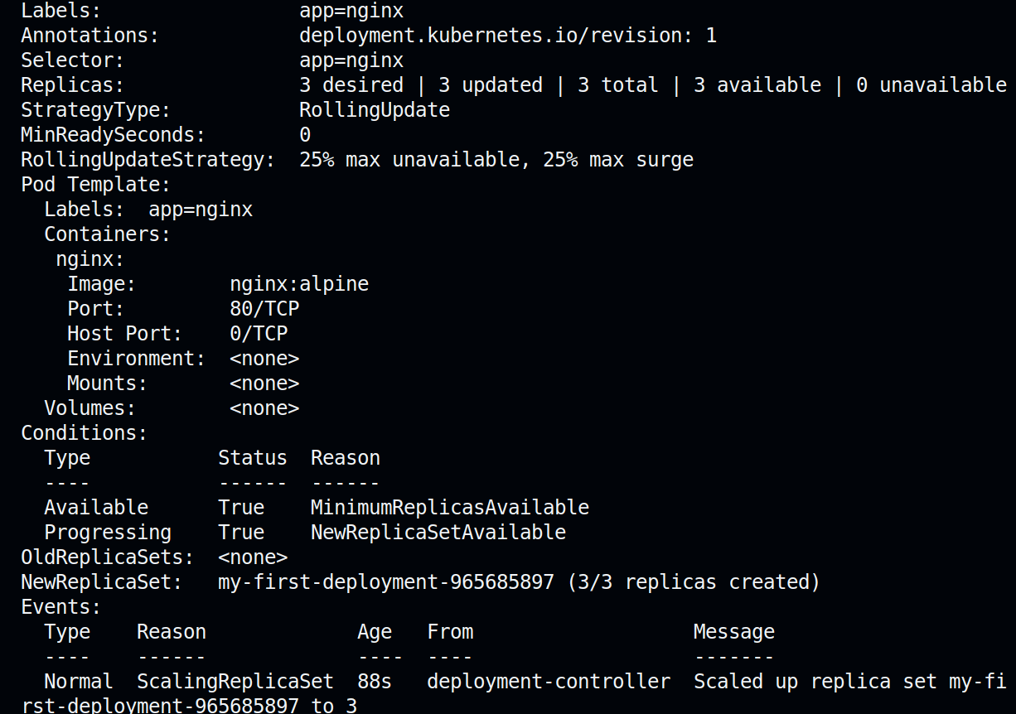

----------------
2-Scale my-first-deployment up to run 3 replicas.
Check to make sure all 3 replicas are ready.

----------------
3-Scale my-first-deployment down to run 2 replicas.

---------------
4-Change the image my-first-deployment runs from nginx:alpine to httpd:alpine .

apiVersion: apps/v1
kind: Deployment
metadata:
name: my-first-deployment
namespace: default
labels:
app: nginx
spec:
replicas: 3
selector:
matchLabels:
app: nginx
template:
metadata:
labels:
app: nginx
spec:
containers:
- name: nginx
image: httpd:alpine
ports:
- containerPort: 80

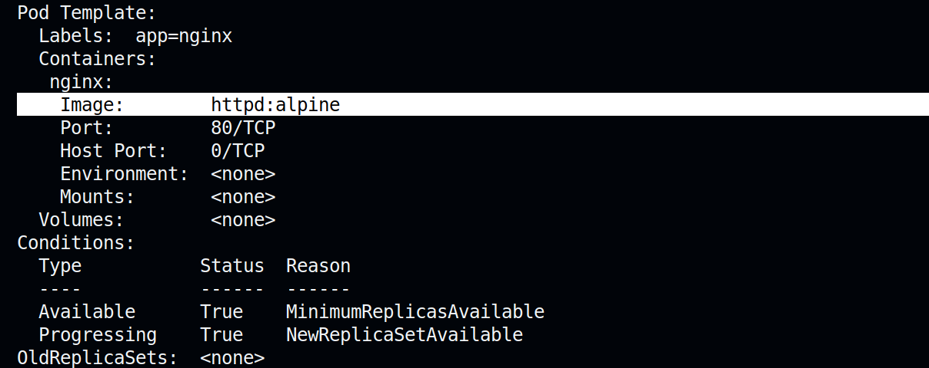

--------------------------
5-Delete the deployment my-first-deployment

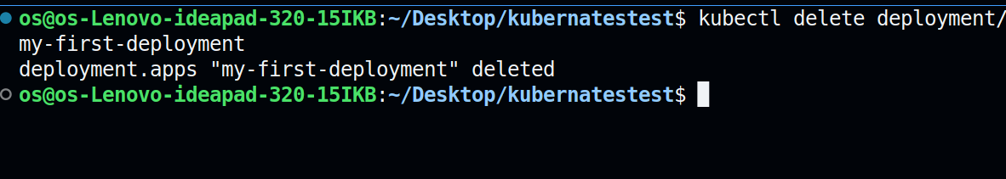

----------------------------
6-Create deployment from the below yaml

apiVersion: apps/v1
kind: Deployment
metadata:
name: frontend-deployment
namespace: default
spec:
replicas: 4
selector:
matchLabels:
name: busybox-pod
strategy:
rollingUpdate:
maxSurge: 25%
maxUnavailable: 25%
type: RollingUpdate
template:
metadata:
labels:
name: busybox-pod
spec:
containers:
- command:
- sh
- -c
- echo Hello Kubernetes! && sleep 3600
image: busybox888
imagePullPolicy: Always
name: busybox-container

-------------
7-How many ReplicaSets exist on the system now?

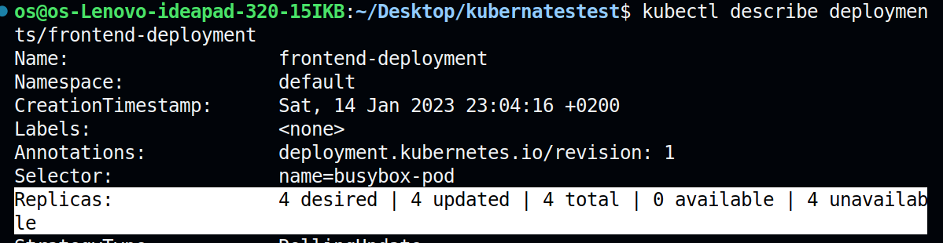

------------------------------
8-How many PODs exist on the system now?

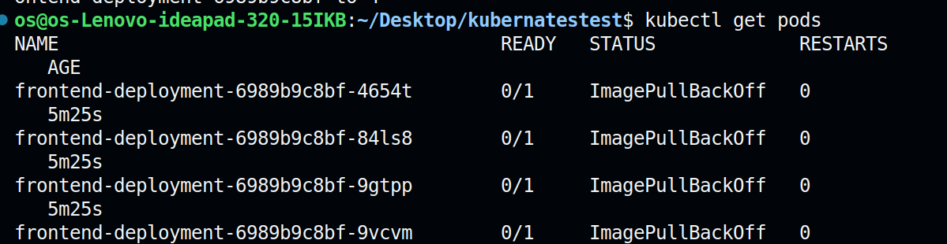
4 pods

-----------------
9-Out of all the existing PODs, how many are ready?

Zero ,because the image is invalid

-------------------
10-What is the image used to create the pods in the new deployment?

image: busybox888

Invalid image

---------------------
11-Why do you think the deployment is not ready?
----------------------
because image is invalid
imagepullbackoff

